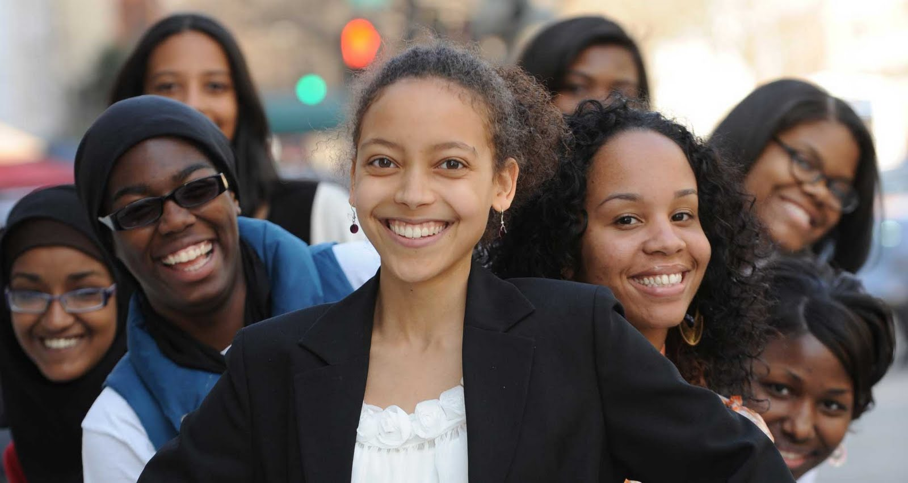  - ndowe  nellona diane offutt williams education scholarship  $1000.00 Collegiate Education Scholarship  NDOWE scholarships are available to underrepresented undergraduate and graduate students matriculating at community and four-year colleges and universities in the United States. Eligible majors include African American Studies, Arts (Music, Fine and Theatrical) Business, Divinity, Education, Medicine, Nursing and Social Work. Candidates must have a 3.0 GPA and must show proof of matriculation at an accredited institution in the state of Illinois. Candidates must complete an essay on the specified topic or question. Scholarship recipients must be present at the 5th Annual Elder’s Tea and NDOWE Scholarship Announcement on March 22, 2026 2:00pm in Springfield, Il.
  NDOWE Scholarship Academic Year 2025-2026
  Brown Sugar and lace
  Elder HOnor and Support Community
  Application Deadline
  March 7, 2026
  Email Applications To:
  jalynpenny1998@gmail.com
  or
  clarissawilliams@ymail.com
  APPLY TODAY!
TO DONATE TO THE NDOWE SCHOLARSHIP FUND, CASH APP $ENDOWER

