nellona diane offutt -williams education scholarship  SUBMIT ALL APPLICATION MATERIALS TO:  brownsugarandlace.com  IL 62704 | 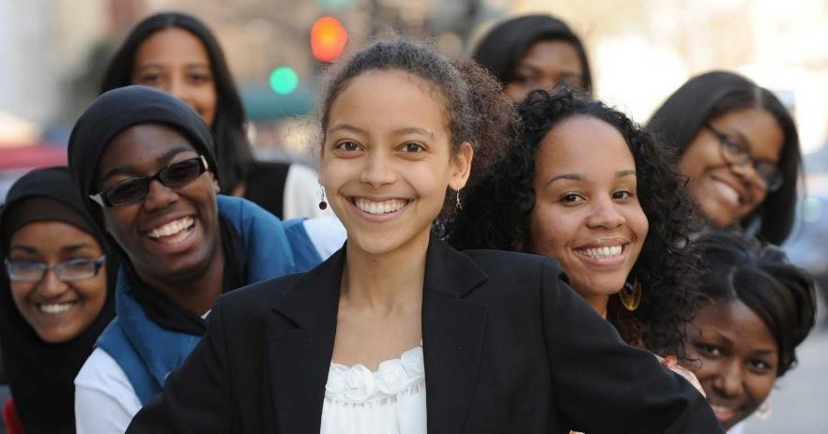  Deadline: March 7, 2027
ndowe

Scholarship Application

Applicant Information
Full Name: |  |  |  | Date:
 | Last | First | M.I.

Address:
 | Street Address |  |  | Apartment/Unit #
 | City | State |  | ZIP Code

Phone: |  | Email
Age: |  |  | Year in School:

College -University
Name
 | Street Address
 | City | State | ZIP Code

Requirements
- 3.0 GPA
- Proof of Matriculation: Class schedule without SSN or letter of continuance for current academic year
- 500-word essay on “How You Intend to Impact the Industry You Will Enter upon graduation.

